**CONTENTS**

* **Fast Facts**
* **2018 Summary**
* **List of Companies that have attended**
* **Press Releases**

**On-Line:** www.HawaiiSmallBusinessConference.com / www.hawaiismall.biz

Facebook: hawaiismallbiz

Twitter: @hawaiismallbiz

#HSBC19 #hawaiismallbiz

**Contact:** **Gerry Smith,** Business Development Manager,

Maui Economic Development Board

1305 North Holopono Street, Suite 1, Kihei, HI 96753

Office: 808-270-6803

Mobile: 808-777-7550

Email: gerry@medb.org

Website: www.medb.org

**Annette Lynch**, Project Manager

Maui Economic Development Board

Office: 808-270-6811

Mobile: 808-280-7414

Email: [annette@medb.org](mailto:annette@medb.org)

**FAST FACTS**

**Description:** The theme of the **Hawaii Small Business Conference** is “Plan, Build, Grow: Mapping A Pathway to Success.”

In 2019 attendees will hear from experts, and successful business owners, on Customer and Employee Engagement, Succession Planning and how to Prepare for Retirement, Technology in Business, Risk Mitigation, Cybersecurity, Tax Strategies and more.

The event coincides with National Small Business Week, an opportunity to recognize the critical contributions of America’s entrepreneurs and small business owners.

Attendees can choose to attend one or both days. On Day 1 the Conference will feature keynote speakers and panel sessions involving local successful business owners.

On the second day, the Conference offers four workshops, with two running concurrently in the morning and two in the afternoon.

Cost is $95 per person for the full-day Conference on May 8th and includes lunch. The May 9th Workshops are $35 per workshop with an additional charge for lunch. Attendees can also save $10 by registering early by April 5 for the full-day Conference.

**Presenters:** This event is presented by **Maui Economic Development Board** and supported by the **County of Maui Office of Economic Development**.

The Maui Economic Development Board (MEDB) is a 501(c)(3) not-for-profit corporation established in 1982 with a mission to diversify Maui County’s economy, building pathways to innovation, jobs and opportunity for our residents.  Through partnerships with the public and private sector, MEDB undertakes projects that assists growth industries with navigating and thriving in our county, educates and trains residents for new careers, and engages our community in forums that determine future economic directions.

The Office of Economic Development is Maui County’s center for advocacy for business development and entrepreneurism for all sectors of our economy. They are dedicated to creating synergy from government to the private sector in Energy, Agriculture, Tourism, Culture and Arts, Film, Workforce Development, and Business Development; and are a catalyst for diversifying Maui’s economy.

**HAWAII SMALL BUSINESS CONFERENCE FAST FACTS** – continued

**Location:** Maui Arts & Cultural Center

One Cameron Way, Kahului, HI 96732

**Event Date:** May 8, 9, 2019

**Sponsors: Enterprise**

Pacific Media Group

The Maui News

**Growth**

Grow with Google

HTDC

**Startup**

ProService Hawaii

**Seed**

Akina Tours

Allstate Insurance - Matthew Cerizo Agency

Coconut Condos

**Featured**

**Speakers: Keynote Speaker TJ Schier**

TJ Schier is the President/Founder of SMART Restaurant Group, a large Which Wich Superior Sandwiches franchisee, as well as a prominent speaker and consultant in the franchise industry. He designs training and guest service programs as well as speaks to managers and franchisees on topics such as building a team of top performers, hiring, guest service and systems.

SMART Restaurant Group won the 2010 QSR Magazine Applied Technology Award and Which Wich Franchisee of the Year, and was a finalist for the National Restaurant Assn Operator Innovations Award in 2012.

TJ has written numerous books including, “S.M.A.R.T. Restaurant Guide to Effective Food Service Operations” as well as ‘Send Flowers to the Living! Rewards, Contests and Incentives to Build Employee Loyalty.” He has authored over 100 articles on guest service and motivating today’s generation. He has a BBA and MBA from the University of Texas and speaks dozens of times per year at manager and franchise conferences.

TJ will be speaking on Day 1 on The 7 Essential Systems for Small Business Success and then moderating a panel on Engaging Your Front Line Increases your Bottom Line. On Day 2 he will go deeper into his 7 Essential Systems in an interactive workshop.

**HAWAII SMALL BUSINESS CONFERENCE FAST FACTS** – continued

**Michael Powers – Tech Entrepreneur and Angel Investor**

Michael Powers is the former Senior VP for CBS interactive. Powers was the second product manager at YouTube where he created the concept of YouTube Channels. He was the founder or early team member of 6 internet startups including 2 acquired by Google.

He is currently living on Maui and continuing to act as an angel investor and advisor to companies such at TaskRabbit (gig marketplace), Turo (car sharing), TurningArt (art print rental), Insight Engines (machine learning) and Origin (blockchain open marketplaces). In addition to startups, he’s held senior positions with Apple, Xerox, Google and most recently was the SVP General Manager of GameSpot and four other gaming properties at CBS Interactive.

Michael will be speaking on Day 1 on Get Seen | Video Marketing for Small Business

**Jules Kremer – Google**

Jules has spent over 20 years in the tech industry focused on software development & business strategy. She joined Google in 2010 leading a global team of strategists and analysts focused on strategic market intelligence. In 2014, Jules moved to the Angular team, managing developer relations & product strategy, and, most recently Jules has taken on leading the Developer Relations teams for Cloud Startups, Higher Education & G Suite Developer Platform.

Prior to Google, she has worked at Microsoft on developer tools, strategy and software architecture and owned a consulting firm providing software solutions to a wide range of businesses. On a personal note, Jules has two children: Gavin, studying computer science at CalPoly Pomona (the apple does not fall far from the tree), and Seren, a varsity cheerleader in Southern California. Jules has a passion for supporting women and kids in tech, bending into pretzel-like positions (otherwise known as yoga), hiking long secluded trails and wielding a machete in the jungles of Maui.

###

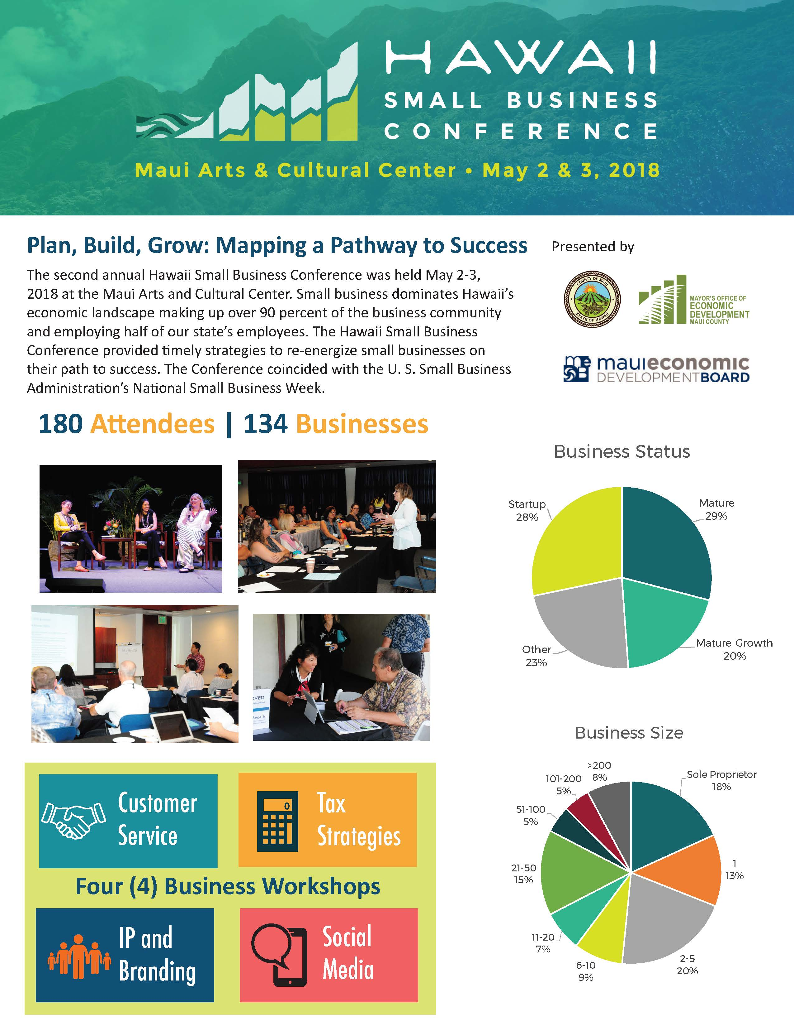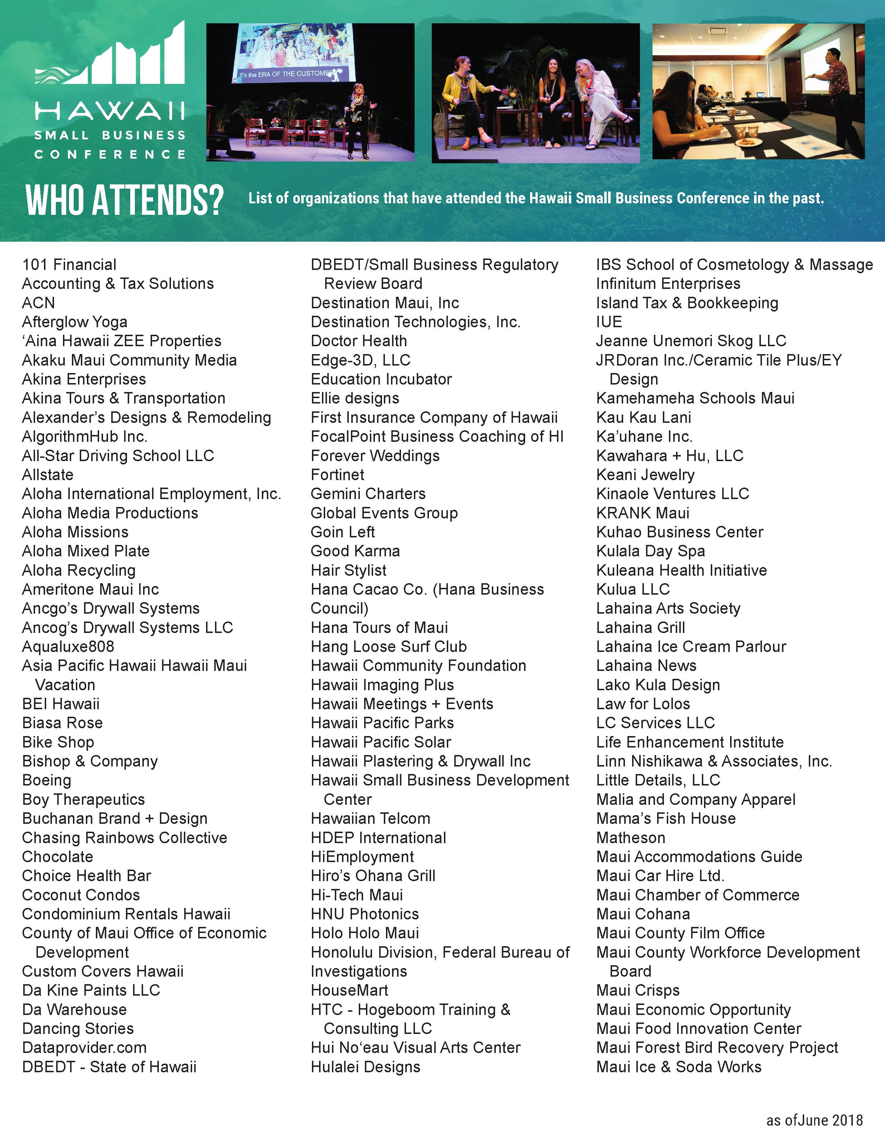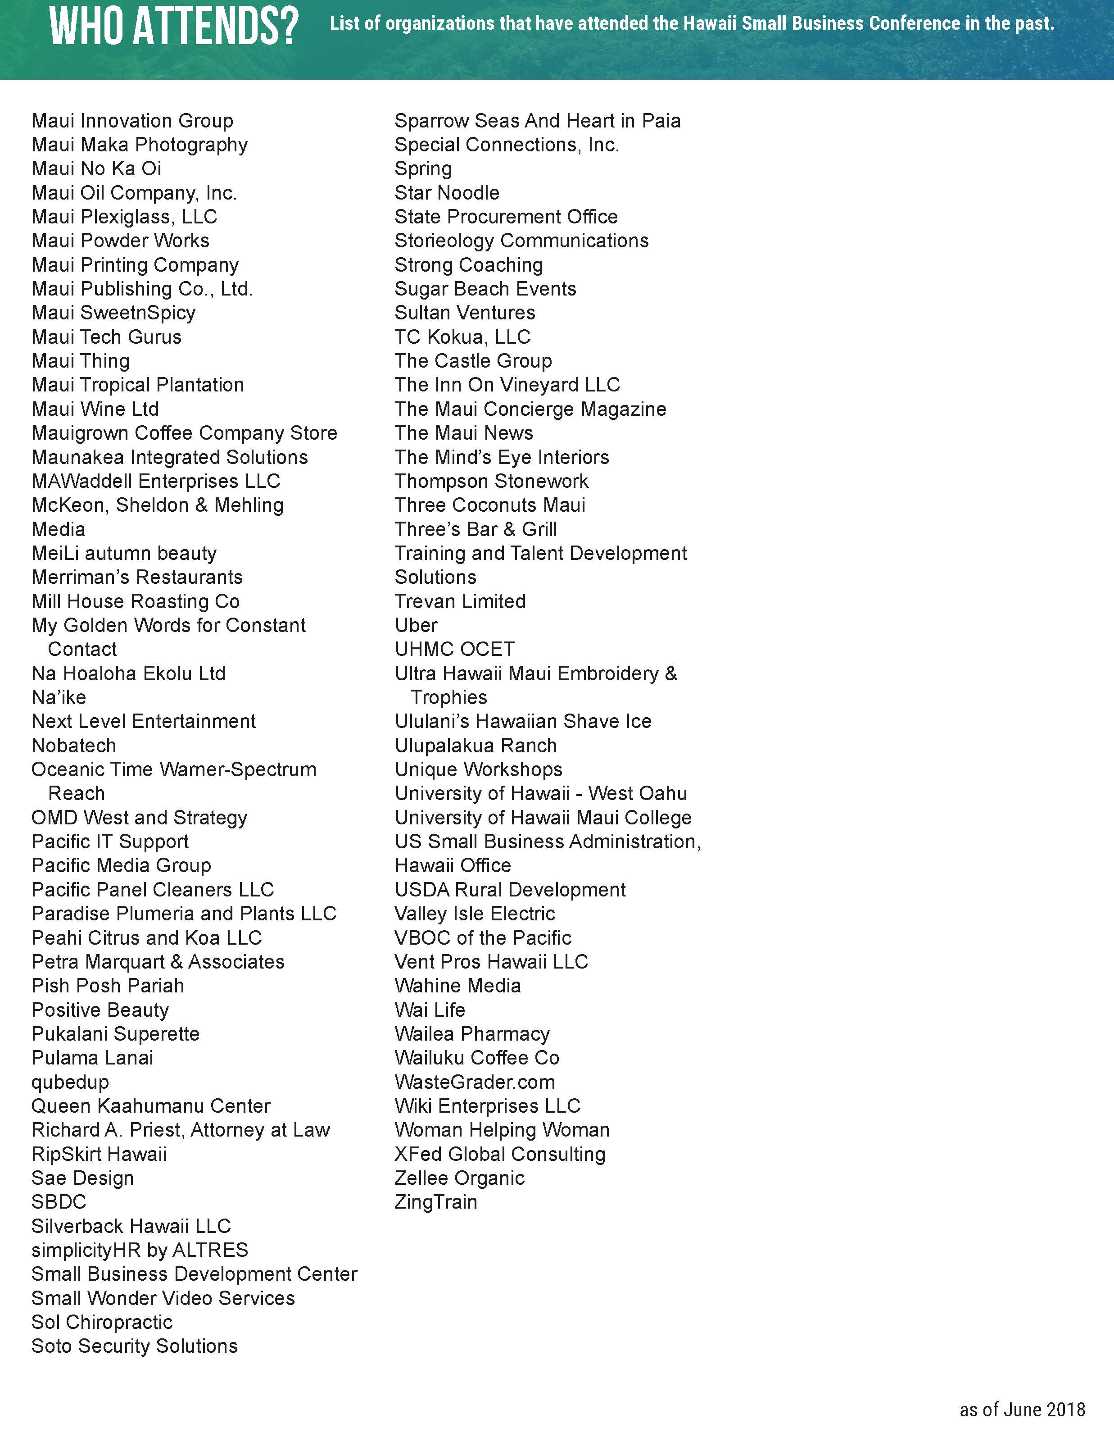

**NEWS RELEASE**

Contact: Linn Nishikawa

Ph: 808-281-0810 / Email: linnpr@hawaii.rr.com

FOR IMMEDIATE RELEASE

**Businesses will learn strategies, keys to success during 3rd Annual Hawaii Small Business Conference**

**KIHEI,** Maui, HI – ***March 28, 2019*** – The 3rd Annual Hawaii Small Business Conference returns to the Maui Arts and Cultural Center May 8 and 9 with another exciting line-up of speakers, topics and workshop. Presented by the Maui Economic Development Board with support by the County of Maui Office of Economic Development, the Conference is an opportunity to learn from business experts and to network.

Business owners, managers, start-ups and entrepreneurs interested in increasing their business knowledge, sharpening their professional skills, expanding their business network, and/or taking their business to the next level are encouraged to attend.

“Unfortunately, most small businesses get so wrapped up in their busy, day-to-day schedules that they don’t make the time to really look at their business to assess what’s not working, what can they do better, and what should they plan for,” said Gerry Smith, MEDB’s Director of Business Development. “This conference was created for these entrepreneurs and their employees. It condenses a number of important, relevant topics into a short period of time; gives people access to experts who provide invaluable insights to expand your knowledge and find solutions to problems; and provides a forum to network with likeminded people and industry peers.”

**On Wednesday, May 8,** presentations led by national and local business leaders and trendsetters will be held in the MACC’s McCoy Theater from 8 am to 5 pm. Among the topics to be covered are employee engagement, technology in business, video marketing, data protection, success planning, tax strategies and more.

Conference speakers will include opening keynote TJ Schier, President/Founder of SMART Restaurant Group speaking on the 7 Essential Systems for Small Business Success. Among the insights Schier will share during the conference is his three-pronged strategy to building a team of top performers. “It includes focusing on the mission or mantra to provide a compass for everyone on the team; retaining the right people and letting the wrong people go work for your competitors; and creating a magnetic culture to attract more of the right people.”

The day includes business owners, such as Rachael Ray from U’I Gallery, Teri Edmonds from If the Shoe Fits and Jason Higa from Zippy’s Restaurants; talking about their business experiences in Talk Story segments.

**On Thursday, May 9,** three-hour workshops will run parallel during morning and afternoon sessions from 9 to 12 noon and 1 pm to 4 pm. Workshop topics will include:

* “The 7 Essential Systems for Small Business Success,” led by TJ Schier
* “Tax Strategies for Small Business,” led by Robert Kawahara, CPA of Kawahara + Company
* “How to Use Free Tools to Grow my Community and Business,” led by Jules Kremer and Alexandrina Garcia-Verdin of Google
* “Intellectual Property and Branding,” led by Bill McKeon, Shannon Mehling, and Rebecca Filipović of Mckeon Sheldon Mehling

**For a full conference schedule and list of presenters, visit** [**www.HawaiiSmall.Biz**](http://www.HawaiiSmall.Biz)**.**

The Hawaii Small Business Conference coincides with National Small Business Week, an opportunity to recognize the critical contributions of America’s entrepreneurs and small business owners.

According to the small business administration, there are more than 115,000 small businesses in Hawaii, representing over 96 percent of all employers and employing more than 54 percent of the private-sector workforce.

“Small businesses are the lifeblood of our economy in Hawaii and it is critical that they be nurtured and protected if we want our overall economy to grow,” said Leslie Wilkins, MEDB’s President and CEO. “That’s one of the main reasons why this conference was created to help small businesses plan, build, and grow in an effort to map out a pathway to their success.”

Cost of the full-day Conference on May 8 is $85 per person for early registration (by April 5), $95 per person for advanced registration, or $100 per person for onsite registration. Conference ​fee ​includes admittance ​to conference sessions, conference ​materials, ​and ​continental ​breakfast ​and ​lunch.

The May 9 Workshops are $35 per workshop with an additional charge for lunch.

To register online, visit [www.HawaiiSmall.Biz](http://www.HawaiiSmall.Biz). For additional information, email [smallbiz@medb.org](mailto:smallbiz@medb.org) or call (808) 875-2300.

Various sponsorship opportunities are available for 2019 Hawaii Small Business Conference. For information, visit [www.HawaiiSmall.Biz](http://www.HawaiiSmall.Biz), email [smallbiz@medb.org](mailto:smallbiz@medb.org), or call (808) 875-2300.

# # #

**PHOTO CAPTIONS:**



Hawaii Small Business Conference Opening Keynote, TJ Schier, will share the 7 Essential Systems for Small Business Success on May 8th. Schier is the President/Founder of SMART Restaurant Group, a large Which Wich Superior Sandwiches franchisee; as well as a prominent speaker and consultant in the franchise industry.

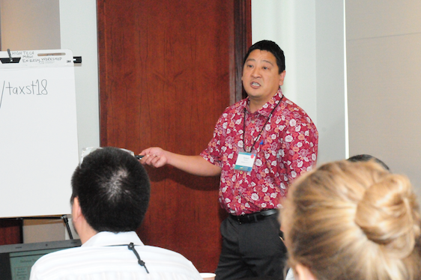

Robert Kawahara, CPA of Kawahara + Co. will address Tax Strategies for Small Business during a Hawaii Small Business Conference workshop on May 9th. *Photo by: Maui Economic Development Board*

**NEWS RELEASE**

Contact: Linn Nishikawa

Ph: 808-281-0810 / Email: linnpr@hawaii.rr.com

FOR IMMEDIATE RELEASE

**Hawaii Small Business Conference workshops**

**will provide tips, tools, insights for business success**

**KIHEI,** Maui, HI – ***April 12, 2019*** – Small businesses interested in gaining invaluable tips on how to create essential systems for success, pay less taxes, expand your reach and impact using free Google apps, and protect your company’s brand are encouraged to attend the Hawaii Small Business Conference workshops on Thursday, May 9.

Now in its third year, the Hawaii Small Business Conference will be held at the Maui Arts & Cultural Center in Kahului, Maui on May 8 and 9, 2019. On the first day of the conference, national and local business leaders and trendsetters will share a number of important strategies for business success. The next day, four interactive workshops will provide additional insights with the opportunity to delve deeper into key topics. For a full conference and workshops schedule visit [*www.HawaiiSmall.Biz*](http://www.HawaiiSmall.Biz)*.*

The three-hour workshop sessions will run parallel both morning (9 am – 12 pm) and afternoon (1pm – 4 pm). Workshops will feature:

TJ Schier, President/Founder of SMART Restaurant Group, leads workshop #1, **“7 Essential Systems for Small Business Success.”** During this workshop, attendees will learn about recruiting and attracting the right talent, creating a customer service culture to beat the competition, implementing effective employee training, accelerating performance with an operational blueprint, maximizing the top- and bottom-line via sales and profit radar, owning the local community, and incentivizing and rewarding performers.

“It’s difficult for small businesses to compete against larger competitors and bigger brands,” said Schier. “However, the weakness with large businesses is they often lack a true connection to the local community and the ability to create a family-atmosphere and culture with their employees. Small business owners need to leverage that advantage and ensure their employees feel like they are appreciated and help deliver a superior guest/client/customer experience.”

During workshop #2, **“Tax Strategies for Small Business,”** Robert Kawahara, CPA, Managing Member of Kawahara + Hu, will share information the how to reduce taxes for your business, the latest tax changes, and how to plan ahead. According to Kawahara, “Taxes can often take a big bite out of the income of a small business and owners need information to make proper business decisions. Understanding taxes and effective tax planning will go a long way in helping you keep more of the money you earn.”

Workshop #3, **“How to Use Free Tools to Grow my Community and Business,”** will be led by Google’s Jules Kremer (Technology Project Manager) and Alexandrina Garcia-Verdin (G Suite Developer Advocate). Kremer shared, “Small business owners have so much to do! From building a business plan, building a team and working with customers. One area we’ve seen in working with small businesses at Google is a need to understand the tools and services that can help you when you are just starting out and as you grow. During this workshop, we’ll share with attendees how Google can help build your business and engage with your customers.”

Workshop #4, **“Intellectual Property and Branding,”** will be led by William McKeon, Keri Mehling and Rebecca Filipovic of McKeon Sheldon Mehling (A Limited Liability Law Company). Attendees will learn what trademarks are, why they are important, and how to develop and protect a strong trademark. According to Filipovic, “A company’s trademark, the brand under which they sell their goods or services, is oftentimes one of their most valuable assets. Developing a strong trademark and taking steps to protect it should be an integral part of any small business strategy from the outset. It also helps owners focus on what their long-term goals or end game might be, whether it’s licensing their brand, manufacturing products or eventually selling the company.”

Cost of the full-day Conference is $95 per person for advanced registration or $100 per person for onsite registration. Conference ​fee ​includes admittance ​to conference sessions, conference ​materials, ​and ​continental ​breakfast ​and ​lunch.

The May 9 Workshops are $35 per workshop with an additional charge for lunch.

To register online, visit [www.HawaiiSmall.Biz](http://www.HawaiiSmall.Biz). For additional information, email [smallbiz@medb.org](mailto:smallbiz@medb.org) or call (808) 875-2300.

The 2019 Hawaii Small Business Conference presented by Maui Economic Development Board with support by the County of Maui Office of Economic Development. Sponsors include:

Pacific Media Group, The Maui News, Maui Chamber of Commerce, Maui Native Hawaiian Chamber of Commerce, Maui Hotel & Lodging Association, Economic Development Alliance of Hawaii.

The Hawaii Small Business Conference coincides with National Small Business Week, an opportunity to recognize the critical contributions of America’s entrepreneurs and small business owners.

# # #

**PHOTOS:**

***No photo credit needed***



**TJ Schier** is the President/Founder of SMART Restaurant Group, a large Which Wich Superior Sandwiches franchisee; as well as a prominent speaker and consultant in the franchise industry.



**Robert Kawahara,** CPA is the Managing Member of Kawahara + Hu, LLC, Maui’s largest CPA firm. The firm is a full-service company providing Individual and Business Tax Planning and Preparation, Audit Services, Estate Planning, Business Valuations, Bookkeeping and Payroll services.



Jules Kremer is a Technical Project Manager at Google. Jules has spent over 20 years in the tech industry focused on software development and business strategy. She current leads the Developer Relations teams for Google’s Cloud Startups, Higher Education and G Suite Developer Platform.



Alexandrina Garcia-Verdin is a G Suite Developer Advocate at Google. She has worked at Google for over six years sharing best practices on how G Suite helps organizations at every phase of its growth along with culture tips and tricks.



**Rebecca Filipovic,** Attorney at McKeon Sheldon Mehling, has expanded her practice to specialize in intellectual property. She has conducted comprehensive trademark searches and has prepared and prosecuted numerous trademarks with the U.S. Patents and Trademarks Office.



Attorney **William McKeon** is the founding member of the Law Offices of McKeon Sheldon Mehling. He represents clients in complex commercial litigation, including real estate, business, construction and personal injury disputes in all the courts in Hawai’i.



**Keri Mehling,** Attorney at McKeon Sheldon Mehling, practices in the areas of commercial litigation, insurance defense, real estate and construction defects.